Increasing Productivity Amid Stable Nutrient Regimes in Rhode Island Lakes and Reservoirs

Hollister. J. W. * *1*, Kellogg, D. Q. *2*, Kreakie, B. J. *1*, Shivers, S. *3*, Milstead, W. Bryan. *1*, Herron, E. *2*, Green, L. *2*, Gold, A *2*

*1* US Environmental Protection Agency, Office Of Research and Development, Atlantic Ecology Division, Narragansett, RI 02882

*2* University of Rhode Island, Department of Natural Resources Science, Kingston, RI 02881

*3* ORISE, Narragansett, RI 02882

* *corresponding author: [hollister.jeff@epa.gov*](mailto:hollister.jeff@epa.gov*)

The University of Rhode Island’s Watershed Watch Volunteer Monitoring Program has been collecting water quality data on Rhode Island lakes and ponds for close to three decades, allowing us to explore long-term trends in common water quality parameters. Not all lakes and ponds in the study area were sampled across the full time period and lakes were often added in geographic clusters (e.g. in urbanized northern Rhode Island). Not unlike how long-term temperature records are analyzed, we centered and scaled (i.e., the z-score) water quality measurements on a per-station basis. This provides a robust and commonly scaled measurement to explore this data for long-term trends. State-wide aggregation shows increasing temperature, chlorophyll *a*, and total nitrogen. Interestingly, total phosphorus is showing a decline, perhaps reflecting the management focus on phosphorus reductions. Contrary to previously reported analyses that show relatively stable water quality at the regional scale, our analysis shows that long-term water quality trends within Rhode Island show some parameters improving while others are in decline. Importantly, this analysis also points out the incredible value and importance of data from long-term monitoring programs, like the Univeristy of Rhode Island’s Watershed Watch, for identifying trends in environmental condition.

# Introduction

Aquatic ecosystems have been altered as the result of human activities modifying nutrient cycling on a global scale [1–3]. Because of their position in the landscape, lakes can function as integrators and sentinels for these anthropogenic effects [4,5]. Increasing nutrient inputs, particularly of N and P, derived from intensive agriculture and densely populated urban areas have contributed to the eutrophication of many lakes [6,7]. Eutrophication has caused the frequency and severity of harmful algal blooms (HABs) to increase, and these blooms are predicted to worsen under a warming climate [8–10]. Increasing HABs will cause further declines in water quality, greater risks for human and animal health, and will be economically costly [11–13]. To address these problems, management strategies have historically focused on reducing P inputs to lakes, but research also suggests that concurrently reducing N inputs may be more effective in certain situations [14,15]. These contrasting studies indicate that spatial differences and relationships between N, P, chlorophyll *a*, and HABs exist and that long-term studies are needed to identify trends at local, regional, and national scales.

Programs such as USEPA’s National Lakes Assessment (NLA) provide data that allows for continental scale water quality analysis. These analyses can be used for managing water resources by developing water quality criteria for N, P, chlorophyll *a*, and microcystin [16,17]. Studying trends across large spatial scales can evaluate the effects of eutrophication such as the degradation of oligotrophic systems as P increases[18]. Large-scale data can also be used for water quality modeling across broad spatial scales including predicting lake trophic state, which can predict ecosystem condition [19,20]. These trophic state models indicate that landscape variables (i.e. ecoregion, elevation, and latitude) are important and that regional trends exist. Lake-specific drivers are also important for predicting continental-scale water quality which adds an additional layer of complexity [21]. Despite these challenges, it is important to study at multiple spatial scales because emergent trends on regional or continental scales may not be evident when studying individual lakes [22,23].

Previous studies using regional data from the northeastern and midwestern United States have investigated spatial and temporal water quality trends and have shown differences based on scale. Macroscale (i.e. subcontinental) drivers of water quality trends are complex and may vary temporally [24]. This complexity can cause nutrient (N and P) trends to have different drivers than ratios of the individual nutrients [25]. On a regional scale, trends of N, P, and chlorophyll *a* differ as factors such as land use and climate vary among regions, particularly when comparing the northeastern and midwestern US [26,27]. Thus, it was surprising when stasis was reported over a 25 year period for these regions [28]. Given what is known about long term trends in water quality within the broader region of the northeastern United States, we were curious if those trends were also present in water quality trends in Rhode Island lakes and ponds.  
Paragraph about awesomeness of WW and volunteer monitoring groups - Betty

Examining long term trends in Rhode Island lakes is possible because of the data gathered by University of Rhode Island’s Watershed Watch (URIWW). URI’s Watershed Watch is a XX year-old citizen science project that has built a robust collaboration between URI scientists and a vast network of non-expert volunteer monitors. Over the past XX years, volunteer monitors are trained and then collect *in situ* data as well as whole water samples during the growing season. These types of citizen science efforts allow for the collection of reliable data that in turn lead to crucial and frequently unexpected insights [29,30]. Often due to lack of resources, these efforts would not happen otherwise. Here specifically, URIWW data contributed to not only the larger subcontinent extent study, but also allowed us to examine the long-term trends of Rhode Island.

Thus, the goals of this study were to look at approximately 25 years of lakes and ponds data in Rhode Island and answer two particular questions. First, what are the state-wide trends in total nitrogen, total phosphorus, chlorophyll *a*, and lake temperature and second, are water quality trends in Rhode Island similar to regional trends in the northeastern United states. In addition to these goals, this analysis has also been done using open data from the URI Watershed Watch program and the LAGOS project and the analysis in its entirety is available for independent reproduction at <https://github.com/usepa/ri_wq_trends> [NEED CITATIONS].

# Methods

For this study we combined a long-term dataset on water quality of lakes in Rhode Island, with a trend analysis based on centered and scaled water quality values (i.e. z-scores) to find increasing or decreasing annual water quality trends. Details are outlined below.

## Study Area and Data

The study area for this analyis includes data in lakes and ponds in the state of Rhode Island that were collected by the University of Rhode Island’s Watershed Watch (URIWW) program (Figure 1). The URIWW is a volunteer monitoring program that has been collecting water quality data from Rhode Island lakes and ponds for over 25 years. The program began in 1988, monitoring 14 lakes and has now grown to include over 250 monitoring sites on over 120 waterbodies, including rivers/streams, and estuaries, with more than 400 trained volunteers. URI WW now provides more than 90% of Rhode Island’s lake multi-year baseline data, and is an integral part of the state’s environmental data collection strategy. Data QA/QC is of paramount importance; volunteers are trained both in the classroom and the field, and are provided with all the necessary equipment and supplies, along with scheduled collection dates. For freshwater lakes and ponds, weekly secchi depth and water temperature are recorded, along with bi-weekly Chl-a and dissolved oxygen. Water samples are collected three times per season (May through October) to be analyzed in the EPA-certified laboratory for nutrients, alkalinity, pH, and bacteria.

*Figure 1: Map of URI Watershed Watch lake and pond sampling sites* 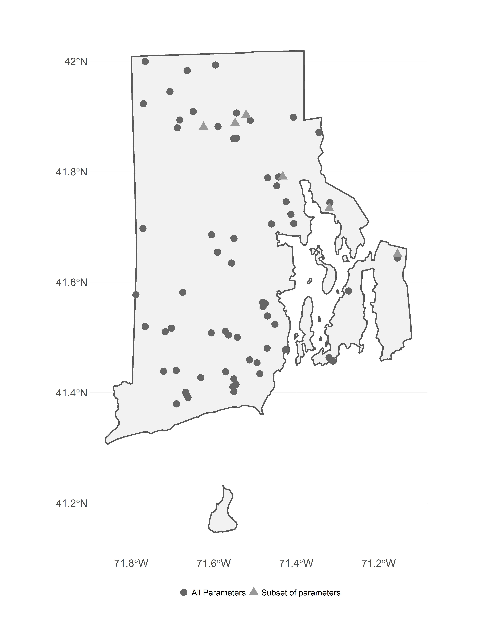

In particular we selected data from the URIWW data that matched the following criteria: 1) were sampled between 1990 and 2016, 2) were sampled in May to October, 3) and were sampled at a depth of 2 meters or less. For this analysis we were interested in trends in lake temperature, total nitorgen, total phosphorus, and chlorophyll *a* and for each of these parameters we further filtered the data to select sites that had at least 10 years of data for a given parameter. The final dataset used in our analysis included 69 lakes and ponds which had approximately 67 samples for temperature, 67 samples for chlorophyll *a*, 65 samples for Total Nitrogen (TN), and 66 samples for Total Phosphorus (TP). Of the 69 sampling sites, 63 had data for all 4 parameters.

Additionally, prior studies have looked at water quality trends across a larger region of the Northeastern United states that included 17 states including Minnesota, Wisconsin, Iowa, Missouri, Illinois, Indiana, Michigan, Ohio, Pennsylvania, New York, New Jersey, Connecticut, Massachusetts, Rhode Island, Vermont, New Hampshire, and Maine [28,31]. The authors found little change in water quality trends across this region [28] . We repeated our analysis (see **Trend Analysis** section) with the same dataset used by [28], the LAGOSNE dataset [31–33]. Temperature data were not availble, thus we only examine trends, using our analytical methods, for Total Nitrogren, Total Phosphorus, and Chlorophyll *a* from the LAGOSNE database.

## Water Quality Trend Analysis

There are many different methods for analyzing time series data for trends. One of the difficulties that is encountered when you have multiple sampling locations is how to identify a trend when you have variation at the scale of the sampling location as well as variation in when a sampling location might have been addedd to a dataset. For instance, if you have long-term data on water quality for several ponds, yet the cleaner ponds wer sampled more frequently in early years then a simple comparison of raw-values over time might show a decrease in water quality. Thus, it is necessary to account for this type of site-specific variation. This is similar to how the long-term temperature trends are analyzed using temperature anomolies [FILL IN GROUP DOING THIS]. The general approach is to calculate site-specific deviations from a long-term mean over pre-determined reference period. This allows all sites to be shifted to a common base line and the deviations, or anomalies, show change relative to the reference period.

### Z-score

The anomaly approach is very useful and is the approach we chose to follow. However, using anomalies works best with a single measure (e.g temperature) or with mulitple measurements that are on the same scale. The water quality parameters that we explored have different scales and thus the anomaly alone is difficult to interpret across metrics. For instance, temperature in Rhode Island lakes during the growing season will range from approximately 15 degrees celsius to a high of 30 degrees celsius, whereas phosphorus might range from near zero ug/l to ~900 ug/l. To standardize these values we used the common approach of dividing each anomaly by the standard deviation for the reference period. This value is commonly referred to as a Z-score. We use these z-scores to examine each water quality variable for a trend over the time period of 1990 to 2016.

Furthermore, since we are interested in water quality trends over time, we wanted to explore how each site was responding. Thus, our z-scores were calculated over the reference period, 1993-2016, for each site. In other words the long-term mean and standard deviation were calculated on a site-by-site basis.

### Summarizing z-scores

Add stuff here. Include an example figure with columns as years, rows as lakes showing how to calc z and summarize.

### Linear regression on yearly means

Testing for a regression slope being different than zero can be used to test for monotonic trends in water quality data [34]. We used these standard procedures to test for postive or negative trends in lake temperature, chlorophyll *a*, total nitrogen, and total phosphorus. For each parameter we fit a regression line to the z scores as a function of year and tested the null hypothesis that no trend existed (e.g. 1 = 0).

### Comparison of Rhode Island to the Region

Prior studies have shown relatively stable water quality in the lakes of the Northeastern United Sates [28]. The data we used in our analysis, the University of Rhode Island’s Watershed Watch data, was inlcuded in that, but we were curious if regional trends were masking local scale trends in Rhode Island. In addition to the analysis condcuted by Oliver et al. [28], we analyzed the same dataset but using the approach outlined here.

# Results

During the sampling period of 1990 to 2016 Rhode Island lakes and ponds average lake temperature was 22.13 celsius, average total nitrogen was 616.83 µg/l, average total phosphorus was 24.82 µg/l, and average chlorophyll was 10.49 µg/l (Table 1).

*Table 1: Summary statistics for URI Watershed Watch data from 1990 to 2016.*

|  |  |  |  |  |  |  |  |
| --- | --- | --- | --- | --- | --- | --- | --- |
| Parameter | Units | 25th Percentile | Mean | Median | 75th Percentile | Max | Std. Dev |
| temp | celsius | 19.0 | 22.13 | 23.00 | 25.5 | 34.2 | 4.37 |
| total_n | µg/l | 355.0 | 616.83 | 470.00 | 710.0 | 19765.0 | 576.11 |
| total_p | µg/l | 10.0 | 24.82 | 15.00 | 25.0 | 1160.0 | 40.77 |
| chla | µg/l | 1.8 | 10.49 | 3.76 | 9.6 | 2104.0 | 26.48 |

For lakes in ponds in the larger region represented by the LAGOSNE States, average total nitrogen was 914.66 µg/l, average total phosphorus was 33.69 µg/l, and average chlorophyll was 17.86 µg/l (Table 2).

*Table 2: Summary statistics for LAGOSNE data from 1990 to 2016.*

|  |  |  |  |  |  |  |  |
| --- | --- | --- | --- | --- | --- | --- | --- |
| Parameter | Units | 25th Percentile | Mean | Median | 75th Percentile | Max | Std. Dev |
| total_n | µg/l | 370.00 | 914.66 | 610 | 1000.00 | 20574 | 1240.04 |
| total_p | µg/l | 10.00 | 33.69 | 16 | 32.00 | 1214 | 59.93 |
| chla | µg/l | 2.83 | 17.86 | 6 | 16.96 | 780 | 36.28 |

## State-wide trends in water quality

Average yearly scaled temperature in lakes and ponds appear to be increasing (slope: 0.013 , p-value: 0.00386) with the large majority of years with average temperature greater than the long term average occuring in the years since 2000 (Figure 2). Chlorophyll *a* is also showing an increasing trend over time (slope: 0.035 , p-value: 0) and with the exception of a slightly above average year in 2003, the above average years have all occurred since 2010 (Figure 3A.).

*Figure 2: Yearly trend over 20+ years of lake temperature in Rhode Island lakes and ponds. Points are averages and ranges are standard deviations with blue indicating an average below the long term mean and red indicating an average above the long term mean.*

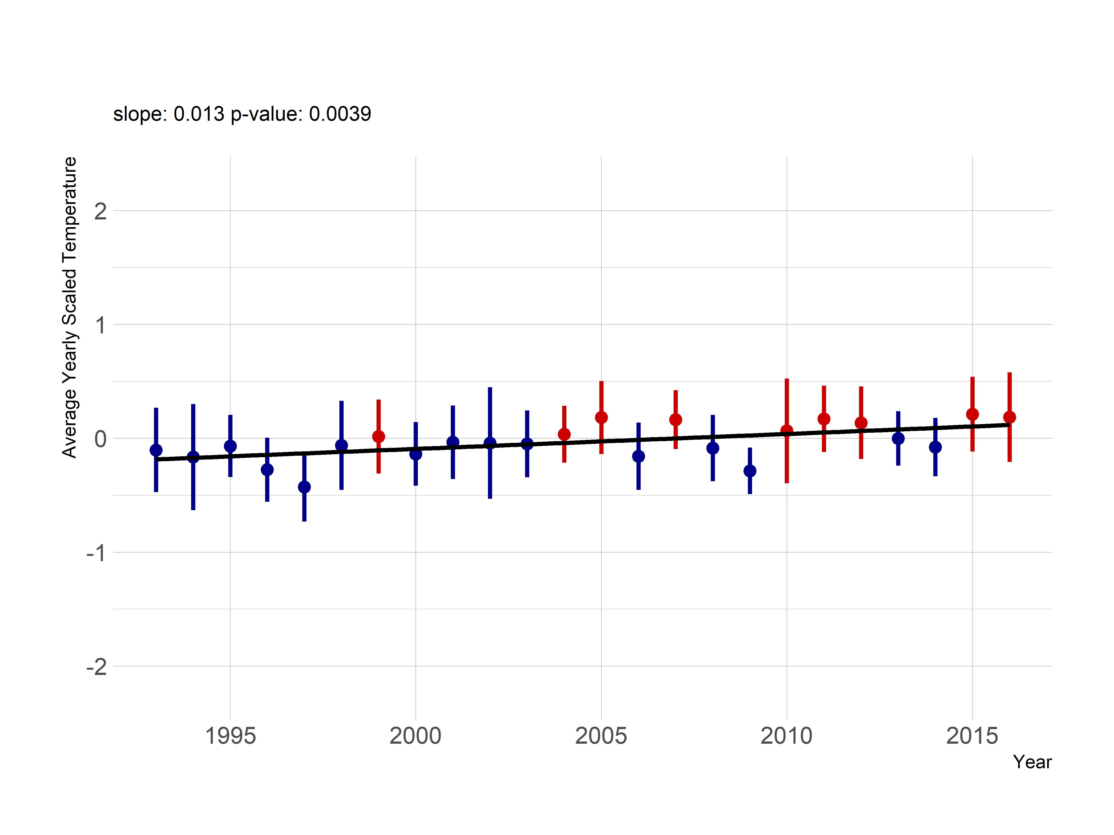

*Figure 3: Yearly trend over 20+ years of chlorphyll *a* (average z-score). Panel A. shows yearly averaged chlorophyll *a* z-scores from the URI Watershed Watch data. Panel B. shows yearly averaged chlorophyll *a* z-scores from the LAGOSNE dataset. Points are averages and ranges are standard deviations with blue indicating an average below the long term mean and red indicating an average above the long term mean.*

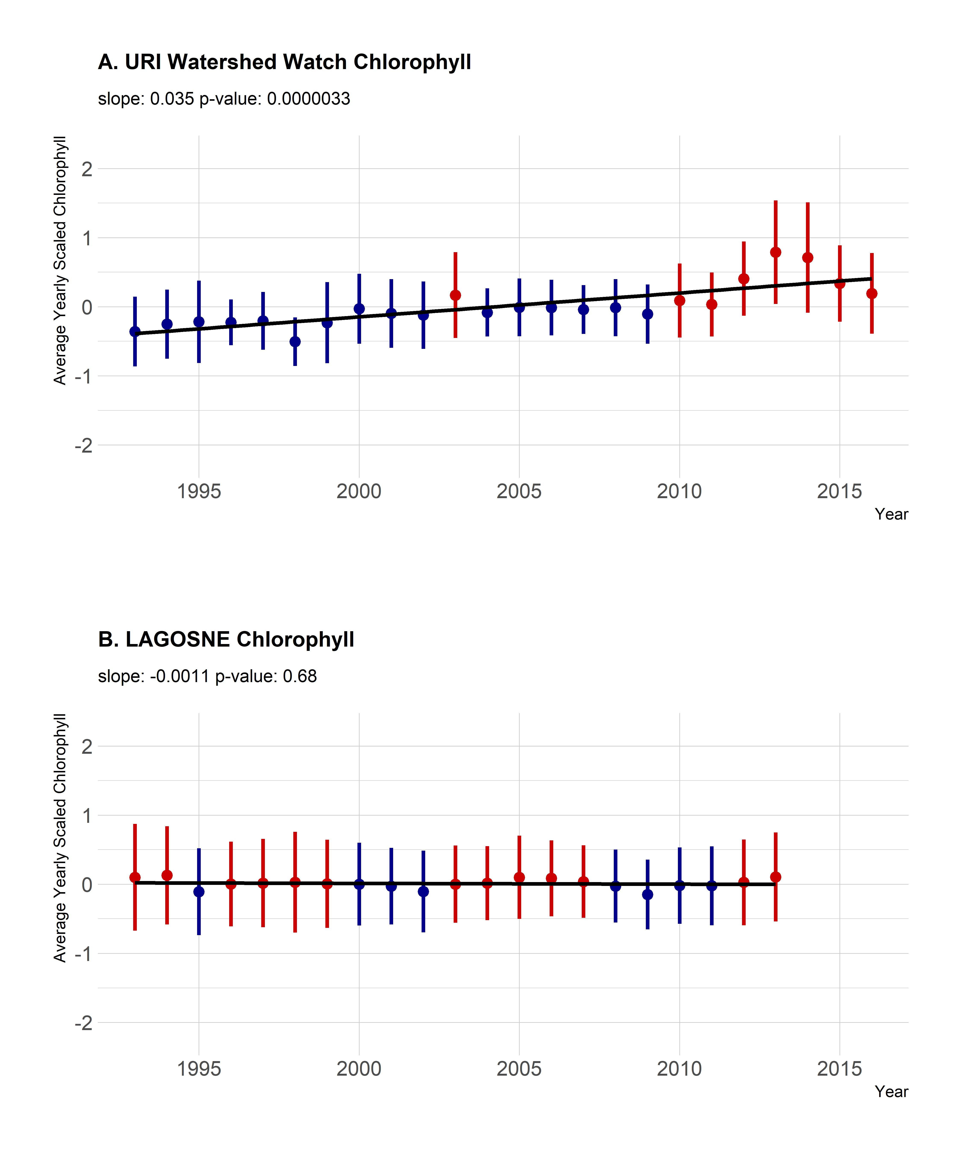

Average yearly trends for nutrients showed weaker or no trends over time. Total nitrogen did suggest a positive trend (slope: 0.018 , p-value: 0.00101); however, that trend is driven by the lower than average total nitrogen values in 1993 and 1994 (Figure 4A.). Since 1995, the yearly trend is shows much lower increase over time (slope: 0.009, p-value: 0.02677). Total phosphorus does not show a trend over time in the yearly scaled values (slope: 0.018 , p-value: 0.00101) and years that are over or under the average are evenly distributed over the years (Figure 5A.). The pattern is the same for the total nitrogren to total phosphorus ratio (slope: 0.008, p-value: 0.291) with little evidence suggesting a change in the concentrations of total nitrogen relative to the concentration of total phosphorus (Figure 6A)

*Figure 4: Yearly trend over 20+ years of total nitrogen (average z-score). Panel A. shows yearly averaged total nitrogen z-scores from the URI Watershed Watch data. Panel B. shows yearly averaged total nitrogen z-scores from the LAGOSNE dataset. Points are averages and ranges are standard deviations with blue indicating an average below the long term mean and red indicating an average above the long term mean.*

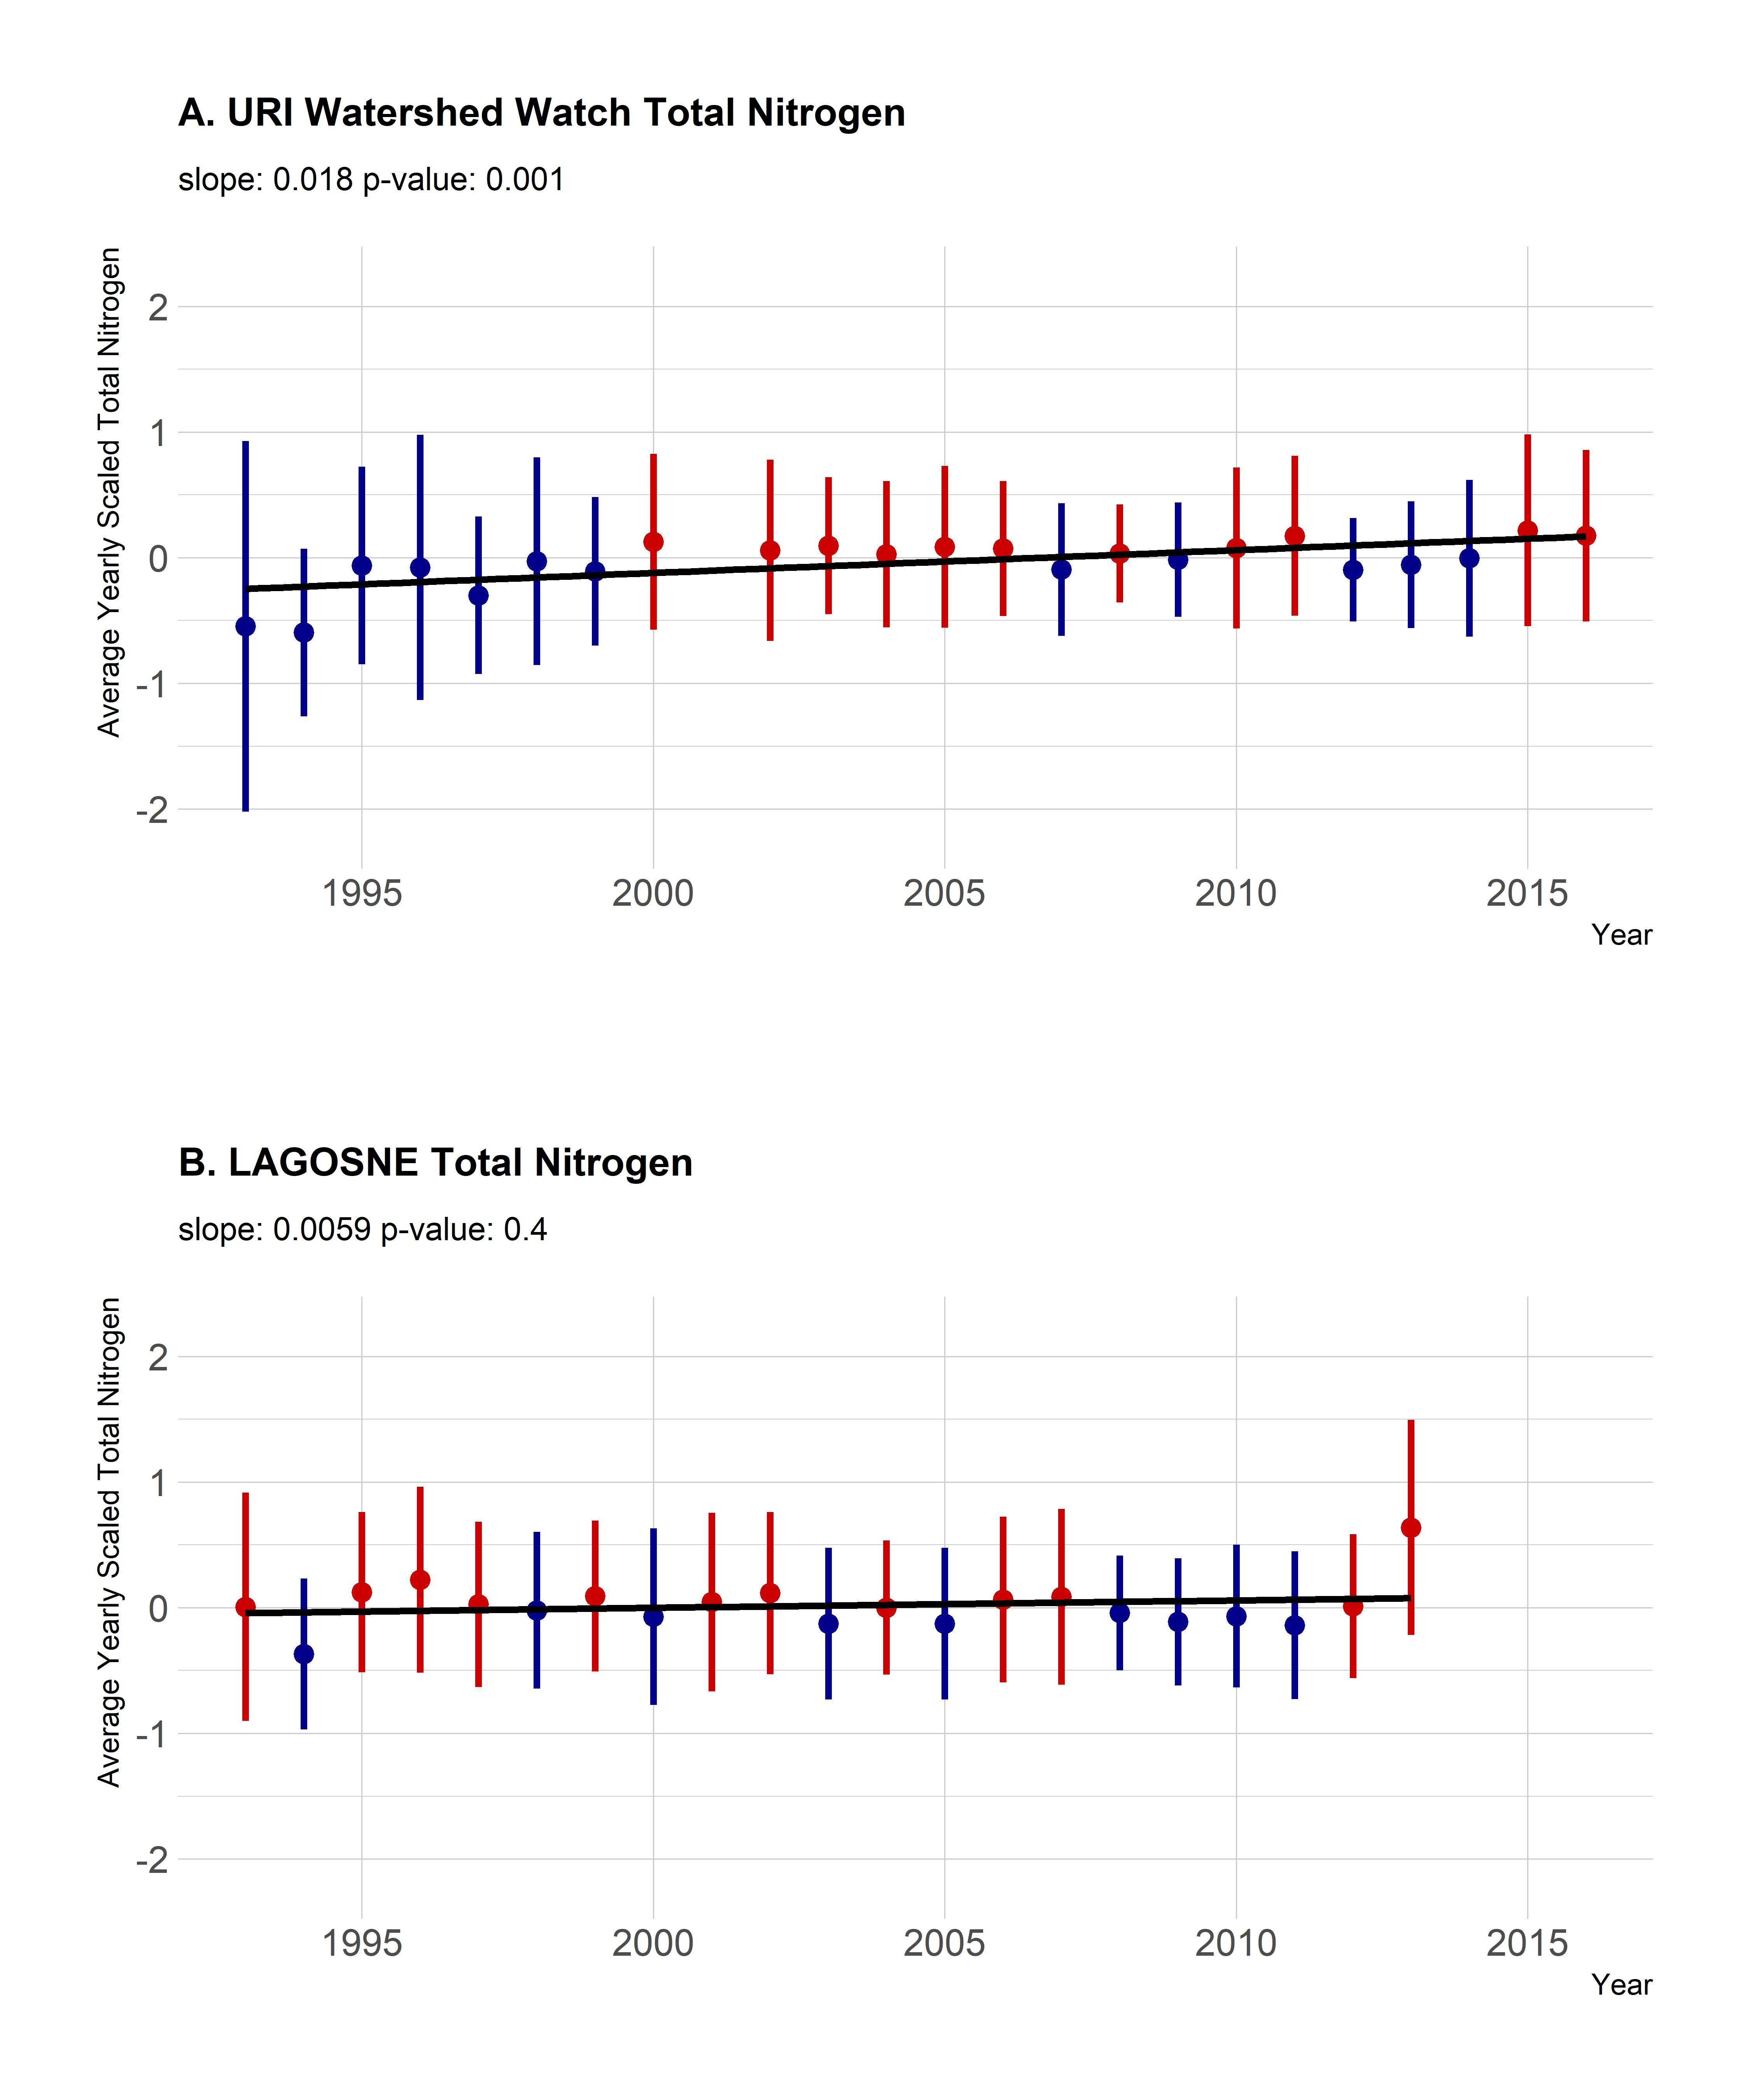

*Figure 5: Yearly trend over 20+ years of total phosphorus (average z-score). Panel A. shows yearly averaged total phosphorus z-scores from the URI Watershed Watch data. Panel B. shows yearly averaged total phosphorus z-scores from the LAGOSNE dataset. Points are averages and ranges are standard deviations with blue indicating an average below the long term mean and red indicating an average above the long term mean.*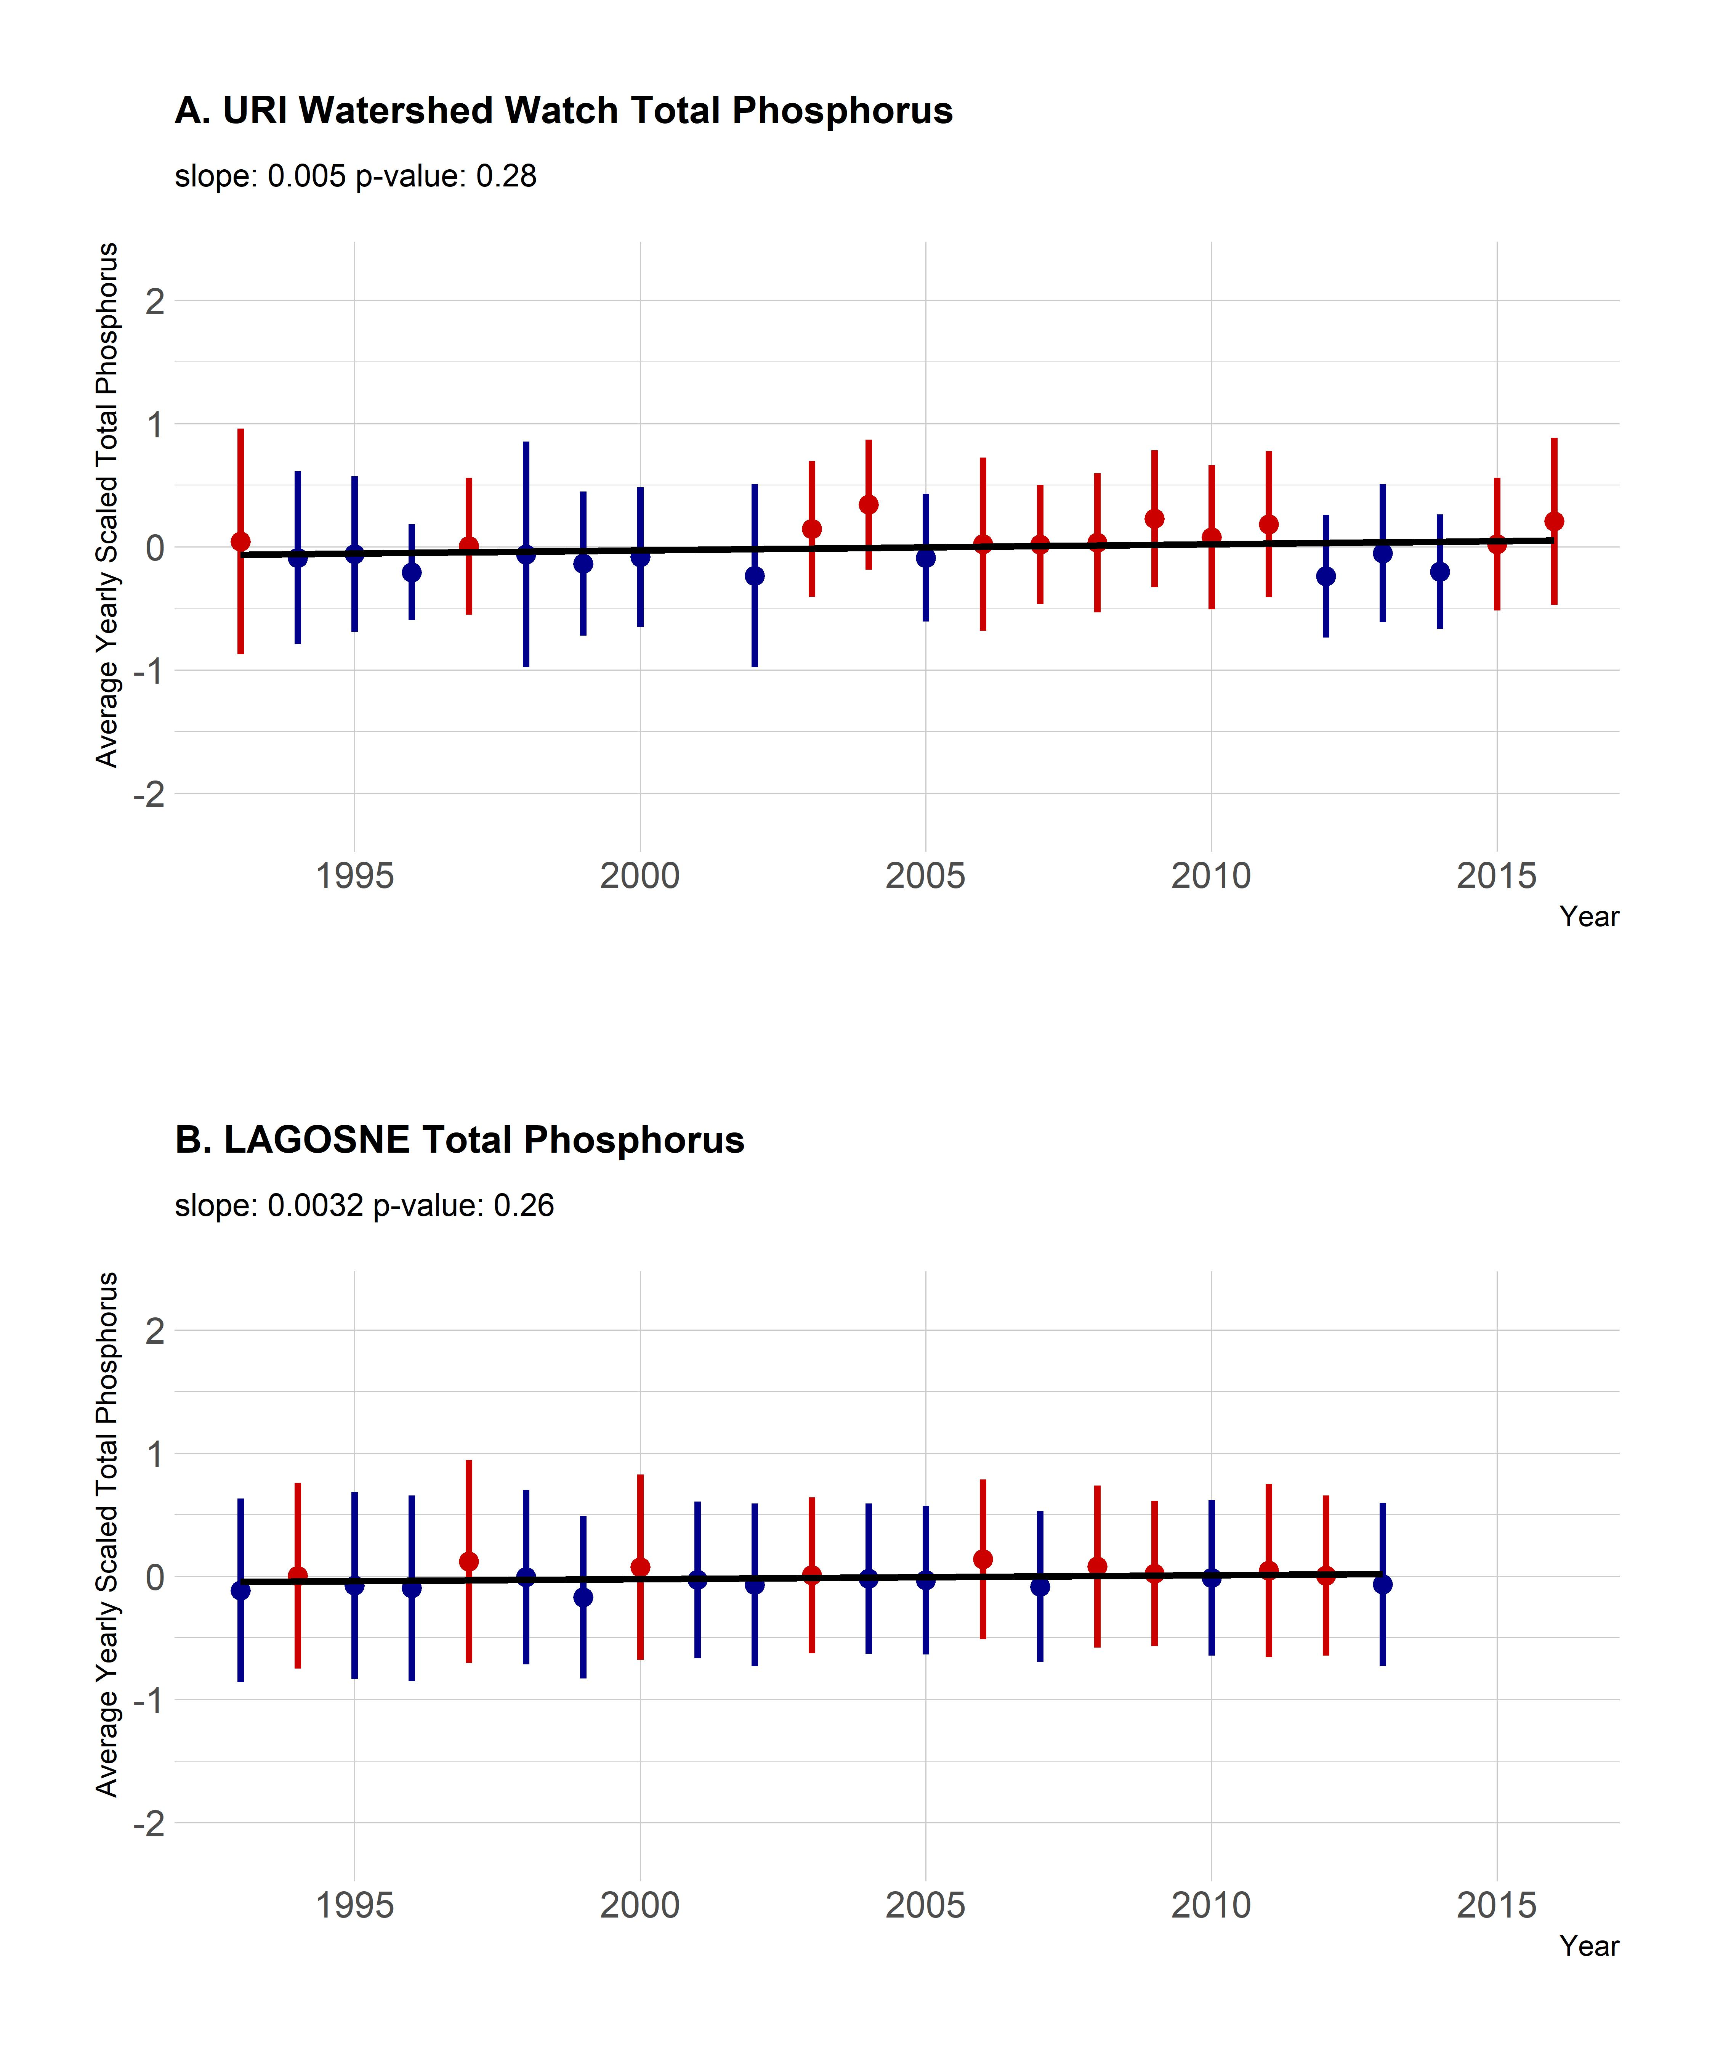

*Figure 6: Yearly trend over 20+ years of the total nitrogen:total phosphorus ratio (average z-score). Panel A. shows yearly averaged total nitrogen:total phosphorus ratio z-scores from the URI Watershed Watch data. Panel B. shows yearly averaged total nitrogen:total phosphorus ratio z-scores from the LAGOSNE dataset. Points are averages and ranges are standard deviations with blue indicating an average below the long term mean and red indicating an average above the long term mean.* 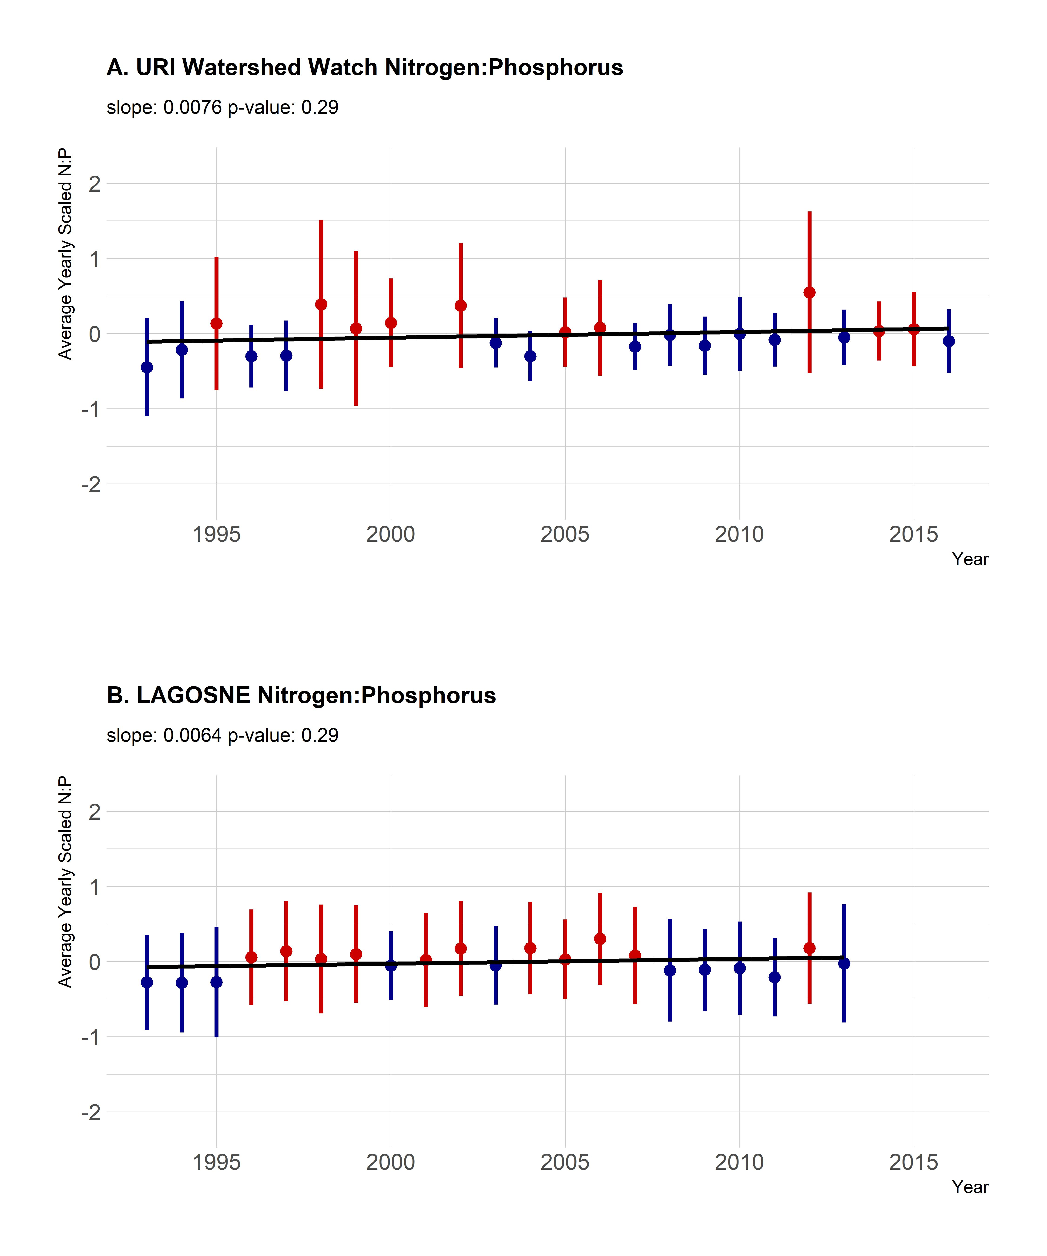

## Regional trends in water quality

In general, there was little to suggest broad regional trends. Chlorophyll *a* showed a very weak negative trend (slope: -0.001, p-value: 0.68038, Figure 3B.), total phosphorus shows a slight increasing trend (slope: 0.003, p-value: 0.2617, Figure 5B.), total nitrogen shows a slight negative trend (slope: 0.006, p-value: 0.39897, Figure 4B.) and the total nitrogen:total phosphorus ratio was also flat (slope: 0.006, p-value: 0.28894, Figure 6B.)

# Discussion and conclusions

## Volunteer Monitoring Data

### Why this is possible - Fantastic WW data

## Trends

### Parameter by parameter discussion of trends

### How do trends break down by trophic state?

### Local scale vs Regional/Global scale

### RI is downstream - Bryan will write

## Management/Implications

### Season Length Changes

## Caveats

# Bibliography

1. Vitousek PM, Aber JD, Howarth RW, Likens GE, Matson PA, et al. (1997) Human alteration of the global nitrogen cycle: Sources and consequences. Ecological applications 7: 737–750.

2. Finlay JC, Small GE, Sterner RW (2013) Human influences on nitrogen removal in lakes. Science 342: 247–250.

3. Filippelli GM (2008) The global phosphorus cycle: Past, present, and future. Elements 4: 89–95.

4. Williamson CE, Dodds W, Kratz TK, Palmer MA (2008) Lakes and streams as sentinels of environmental change in terrestrial and atmospheric processes. Frontiers in Ecology and the Environment 6: 247–254.

5. Schindler D (2009) Lakes as sentinels and integrators for the effects of climate change on watersheds, airsheds, and landscapes. Limnology and Oceanography 54: 2349–2358.

6. Carpenter SR, Caraco NF, Correll DL, Howarth RW, Sharpley AN, et al. (1998) Nonpoint pollution of surface waters with phosphorus and nitrogen. Ecological applications 8: 559–568.

7. Smith VH (2003) Eutrophication of freshwater and coastal marine ecosystems a global problem. Environmental Science and Pollution Research 10: 126–139.

8. Michalak AM, Anderson EJ, Beletsky D, Boland S, Bosch NS, et al. (2013) Record-setting algal bloom in lake erie caused by agricultural and meteorological trends consistent with expected future conditions. Proceedings of the National Academy of Sciences 110: 6448–6452.

9. Kosten S, Huszar VL, Bécares E, Costa LS, Van Donk E, et al. (2012) Warmer climates boost cyanobacterial dominance in shallow lakes. Global Change Biology 18: 118–126.

10. Taranu ZE, Gregory-Eaves I, Leavitt PR, Bunting L, Buchaca T, et al. (2015) Acceleration of cyanobacterial dominance in north temperate-subarctic lakes during the anthropocene. Ecology Letters 18: 375–384.

11. Brooks BW, Lazorchak JM, Howard MD, Johnson M-VV, Morton SL, et al. (2016) Are harmful algal blooms becoming the greatest inland water quality threat to public health and aquatic ecosystems? Environmental toxicology and chemistry 35: 6–13.

12. Dodds WK, Bouska WW, Eitzmann JL, Pilger TJ, Pitts KL, et al. (2008) Eutrophication of us freshwaters: Analysis of potential economic damages.

13. Paerl HW, Huisman J (2009) Climate change: A catalyst for global expansion of harmful cyanobacterial blooms. Environmental microbiology reports 1: 27–37.

14. Paerl HW, Scott JT, McCarthy MJ, Newell SE, Gardner WS, et al. (2016) It takes two to tango: When and where dual nutrient (n & p) reductions are needed to protect lakes and downstream ecosystems. Environmental science & technology 50: 10805–10813.

15. Schindler DW, Hecky R, Findlay D, Stainton M, Parker B, et al. (2008) Eutrophication of lakes cannot be controlled by reducing nitrogen input: Results of a 37-year whole-ecosystem experiment. Proceedings of the National Academy of Sciences 105: 11254–11258.

16. Herlihy AT, Kamman NC, Sifneos JC, Charles D, Enache MD, et al. (2013) Using multiple approaches to develop nutrient criteria for lakes in the conterminous usa. Freshwater Science 32: 367–384.

17. Yuan LL, Pollard AI, Pather S, Oliver JL, D’Anglada L (2014) Managing microcystin: Identifying national-scale thresholds for total nitrogen and chlorophyll a. Freshwater biology 59: 1970–1981.

18. Stoddard JL, Van Sickle J, Herlihy AT, Brahney J, Paulsen S, et al. (2016) Continental-scale increase in lake and stream phosphorus: Are oligotrophic systems disappearing in the united states? Environmental science & technology 50: 3409–3415.

19. Hollister JW, Milstead WB, Kreakie BJ (2016) Modeling lake trophic state: A random forest approach. Ecosphere 7.

20. Nojavan F, Kreakie BJ, Hollister JW, Qian SS (2019) Rethinking the lake trophic state index. PeerJ Preprints.

21. Read EK, Patil VP, Oliver SK, Hetherington AL, Brentrup JA, et al. (2015) The importance of lake-specific characteristics for water quality across the continental united states. Ecological Applications 25: 943–955.

22. Cheruvelil K, Soranno P, Webster K, Bremigan M (2013) Multi-scaled drivers of ecosystem state: Quantifying the importance of the regional spatial scale. Ecological Applications 23: 1603–1618.

23. Lottig NR, Wagner T, Henry EN, Cheruvelil KS, Webster KE, et al. (2014) Long-term citizen-collected data reveal geographical patterns and temporal trends in lake water clarity. PloS one 9: e95769.

24. Lottig NR, Tan P-N, Wagner T, Cheruvelil KS, Soranno PA, et al. (2017) Macroscale patterns of synchrony identify complex relationships among spatial and temporal ecosystem drivers. Ecosphere 8.

25. Collins SM, Oliver SK, Lapierre J-F, Stanley EH, Jones JR, et al. (2017) Lake nutrient stoichiometry is less predictable than nutrient concentrations at regional and sub-continental scales. Ecological applications 27: 1529–1540.

26. Filstrup CT, Wagner T, Soranno PA, Stanley EH, Stow CA, et al. (2014) Regional variability among nonlinear chlorophyll—phosphorus relationships in lakes. Limnology and Oceanography 59: 1691–1703.

27. Filstrup CT, Wagner T, Oliver SK, Stow CA, Webster KE, et al. (2018) Evidence for regional nitrogen stress on chlorophyll a in lakes across large landscape and climate gradients. Limnology and Oceanography 63: S324–S339.

28. Oliver SK, Collins SM, Soranno PA, Wagner T, Stanley EH, et al. (2017) Unexpected stasis in a changing world: Lake nutrient and chlorophyll trends since 1990. Global Change Biology 23: 5455–5467. Available: <https://doi.org/10.1111%2Fgcb.13810>.

29. Dickinson JL, Shirk J, Bonter D, Bonney R, Crain RL, et al. (2012) The current state of citizen science as a tool for ecological research and public engagement. Frontiers in Ecology and the Environment 10: 291–297.

30. Kosmala M, Wiggins A, Swanson A, Simmons B (2016) Assessing data quality in citizen science. Frontiers in Ecology and the Environment 14: 551–560.

31. Soranno PA, Bissell EG, Cheruvelil KS, Christel ST, Collins SM, et al. (2015) Building a multi-scaled geospatial temporal ecology database from disparate data sources: Fostering open science and data reuse. GigaScience 4: 28.

32. Stachelek J, Oliver S (2017) LAGOSNE: Interface to the lake multi-scaled geospatial and temporal database. Available: <https://cran.r-project.org/package=LAGOSNE>.

33. Soranno P, Bacon L, Beauchene M, Bednar K, Bissell E, et al. (2017) LAGOS-ne: A multi-scaled geospatial and temporal database of lake ecological context and water quality for thousands of us lakes. Gigascience 6.

34. Helsel DR, Hirsch RM (2002) Statistical methods in water resources. US Geological survey Reston, VA, Vol. 323.